Exercise 7: Implementing Constructor and Setter Injection
Folder structure
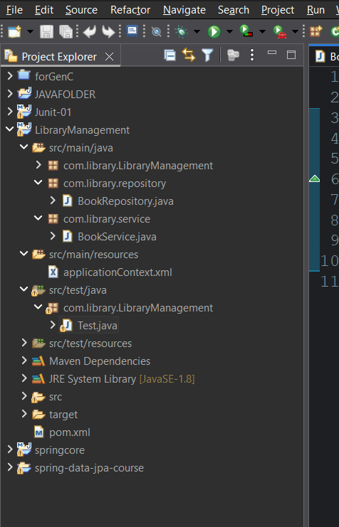
BookRepository class:
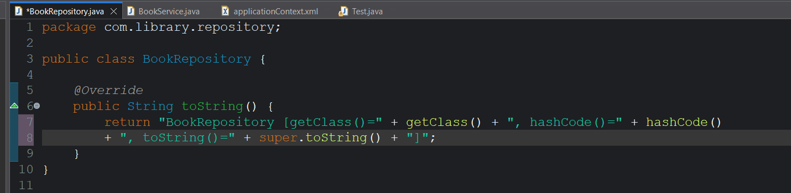

BookService class:
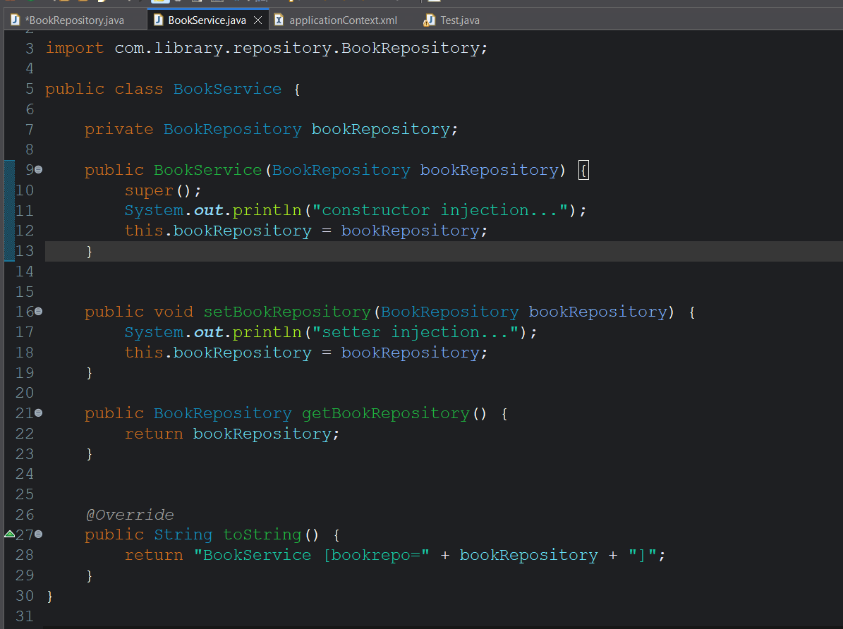
Add both constructor and setter methods
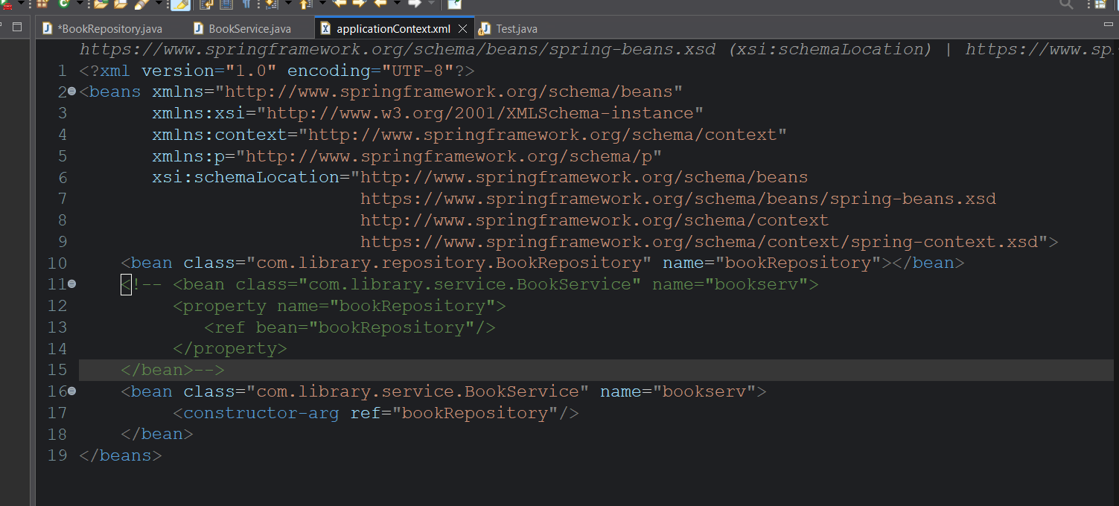
Add both construction-arg and property for implementing both constructor and setter injection.

Testing class
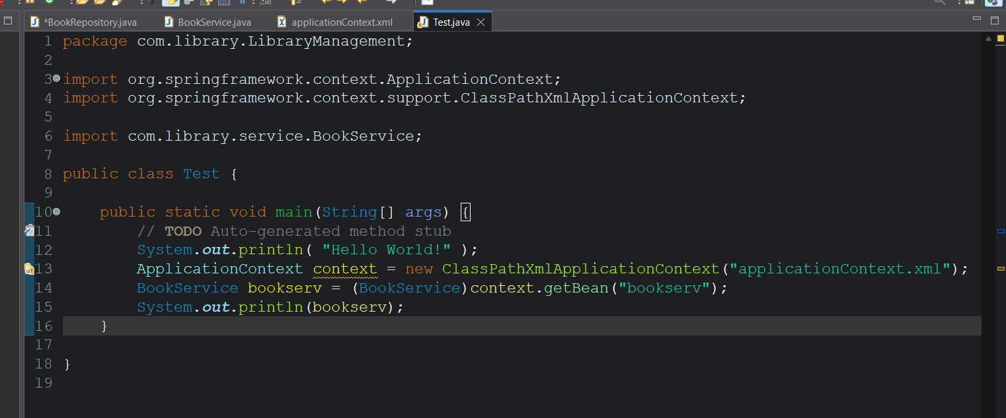
Output for constructor injection:
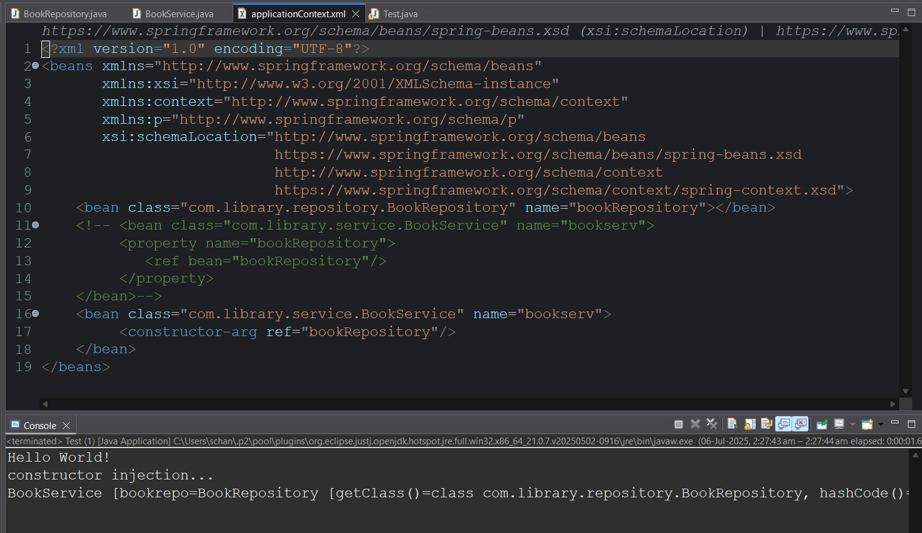
Output for setter injection:
